
21st International Convention
Motion

Spaces of Human Experience

Warsaw, 13th-15th June 2019

Booklet
of Abstracts

Invited Speakers
Tiziano Agostini
University of Trieste


Rhythm: a Gestalt of Human Movement
Co-authors: Giulio Baldassi, Fabrizio Sors, Serena Mingolo, Mauro Murgia
In 2006 on Gestalt Theory, we published a paper titled “Rhythm, a gestalt of human movement?”. The question mark was strongly suggested because the number of empirical evidences supporting this claim was still too limited. Thirteen years later, after that many experimental proofs, in different research domains, had fully supported this claim, we are quite confident in removing the question mark from the title. In our studies, we obtained 3 main results: 1) We observed that the cyclical movements of human body can be accurately represented by an acoustic stimulus having definite rhythmical characteristics and that this acoustic stimulus can be easily recognized by who has produced it. 2) We found that ecological sounds (the real sounds produced by real body movements) are more efficient than artificial sounds in building up an effective motor action mental representation. 3) We discovered that auditory information is an important feedback to exert a more accurate control of timing in terms of improvement and standardization of a specific movement. This evidence offer important indications to develop applied strategies to standardize and to improve motor execution that can indirectly affect cognitive functions.
Contact: agostini@units.it

Michael Buchholz
International Psychoanalytic University (IPU), Berlin

Movement in therapeutic spaces – Seeing the Situational Gestalt
Psychotherapy Process Research arrived at a state where the cultural “transdiagnostic characteristics” like gender, age, colour, religious and spiritual orientation, income, class etc. (Norcross & Wampold 2018) are considered as stronger guides for how therapists work than schematic diagnostic classification (like DSM or ICD). A new space for individualization of psychotherapy is open which allows a more precise look into conversational practice in the treatment room. I want to present some results of a study of typical situations (Co-Constructed Utterances – CCU; agenda transforming utterances – ATU; typical problematic situations – TPS). These emerge as situational gestalts with a rhythmical contour which can be described. In a second part I want to make visible how the “display of neutrality” by a therapist contributes to the outcome of a session. A look at gaze behavior and head movement will be presented.
Contact: buchholz.mbb@t-online.de

Angelo Giavatto
Université de Nantes et Centre Atlantique de Philosophie
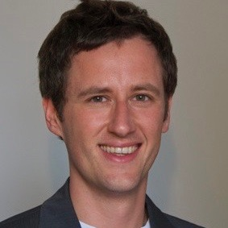
Kinêsis. Or how to go beyond human limits through movement
Human beings turn out to be limited in space (they occupy a limited space), in time (they live a limited existence), in their faculties (they can lift weights up to a certain point, they walk and run at limited speeds, they have cognitive faculties which are remarkable, but not unlimited). At the same time, human beings yearn for the unlimited, certainly because of the boundlessness of their imagination or just for an intimate fear of death. In this paper I will discuss some aspects of ancient Greek thought which can suggest a theory of movement conceived as a strategy emerging from our limitedness, and capable of going beyond it. In order to conceive this, ancient philosophers ask us to accept a broader conception of movement that I will define all along my paper. In addition, I will try to show [a] that temporality is the main condition of our limitedness and [b] that movement allows us to achieve a kind of boundlessness which is peculiarly human. Inter alia, this specific kind of boundlessness allows human beings to take some distance from their traditional model of freedom from limits, namely the divine, the eternal, the unchanging. Through this they can recognise and incorporate the preciousness of their limited presence in reality.
Contact: angelo.giavatto@univ-nantes.fr

Elżbieta Jung
University of Łodż


Between Ancient and Modern Times: the Theory of Motion in the 14th Century
The impulse to this talk has been provided by the growing interest in the study of medieval philosophy of nature that produced numerous editions of commentaries on Aristotle’s Physics followed by many studies dealing with medieval physics and its links with the seventeenth century physics. These studies reveal the importance of medieval science and argue for its role in developing modern theories. Since medieval philosophers of nature never abandoned the realm of Aristotelian physics nor rejected the principles laid down in his natural philosophy, it is interesting to answer the question whether the various methods that they applied to surmount the inconsistency of Aristotle’s theory made them stand any closer to modern science. It is here that we see the Oxford Calculators (Richard Kilvington, Thomas Bradwardine, Roger Swineshead, John Dumbleton, Richard Swineshead)– the fourteenth century logicians, mathematicians and philosophers of nature. They are best known for their new movement theory and, especially for the Mean Speed Theorem, later used by Galileo to establish a proper rule of accelerated motion. From the point of view of modern, Newtonian physics focused on establishing rules of local motion in both dynamical and kinematical aspects, Aristotle’s libri naturales, seem to be full of superfluous and vague speculations. The use of ‘motion’ as the concept synonymous to ‘change’ allows for the inclusion of problems concerning alteration, augmentation, generation and corruption into the field of natural philosophy. Consequently, local motion, which is the main subject of modern physics, is curtained by discussions of different kinds of changes, (e.g. becoming white, or change from not being into being). Aristotle’s rules of motion, formulated in Book VII of his Physics not only mix kinematic and dynamic aspects of motion and they are far away from mathematical precision and can hardly be called laws of dynamics. Aristotle’s modus operandi in science resulting in separation of mathematics and physics makes it difficult to describe physical phenomena properly. The readers of Aristotle’s Physics, however, receive the book that describes the world at large, where each event can be explained by the same set of rules. On one hand, Aristotle claims he can explain the structure of the physical world and give a convincing explanation of its phenomena. On the other hand, because of the numerous aporiae, he leaves his readers with many doubts concerning particular problems. Medieval philosophers noticed this incongruity of Aristotle’s Physics and tried to overcome the difficulties. One of the most popular methods in philosophy of nature, which was the novelty of the 14th century and might be treated as the first attempt to overcome inconsistency in Aristotelian theory, was to apply both logic and mathematics into physics. This procedure solved many problems in natural philosophy and allowed to use mathematics as the proper language of physics. Oxford Calculators were the vanguard of mathematical physics in the Middle Ages.
Contact: fhjung@uni.lodz.pl

Mikhail Kotin
University of Zielona Góra
Sein und Bewegung im Spiegel der Sprache: Zur Versprachlichung spatialer und direktionaler Konzepte

Im Vortrag werden die wichtigsten Kodierungsformen von Spatium und Bewegung durch Sprachformen behandelt. Dabei wird dafür argumentiert, dass das Konzept ORT, welches bekanntlich zu den „semantischen Primitiva“ gehört, primär und die Veränderung der Ortslage (Bewegung) als eine komplexe deiktische Prozedur sekundär, davon abgeleitet ist. Dies findet eine angemessene Widerspiegelung in den natürlichen Sprachen. So werden germanische schwache Verben der sog. „accomplishment“-Klasse (Vendler 1957) von den starken „states“ (ibid.) abgeleitet (vgl. liegen → legen, stehen → stellen, sitzen → setzen). Direktionale deiktische Signale sind von spatialen abgeleitet (vgl. wo? → wohin?, da → dahin, dort → dorthin, hier → hierher). Der Adressaten-Dativ wird historisch vom Lokativ abgeleitet; Zwischenstufen sind die Bedeutungen der Zugehörigkeit und der Annäherung, also „hier“ → „nahe“ → „bei X“ → „gehört X“ → nähert sich dem X“ → „wechselt den Besitzer“, vgl. auf dem Boden → nahe zum Boden / zu mir → gehört mir → nähert sich mir → gibt mir Z. Der Direktional-Akkusativ wird vom Lokal-Dativ in der ambigen Präpositionalangabe abgeleitet: In der Schule sein → in die Schule gehen. Das lokal verankerte SEIN-Konzept ist die Quelle des direktional verankerten WERDEN-Konzepts. Das komplexeste TUN-Konzept, welches die Valenz der dazu gehörigen Verben steigert, ist ebenfalls eine Ableitung vom genuinen SEIN und dem unmittelbar davon stammenden WERDEN-Konzept und kann entsprechend reanalysiert werden.
Contact: michailkotin1@gmail.com

Hilge Landweer
Freie Universität Berlin



Die Räumlichkeit der Gefühle
Im Alltag wird oft davon gesprochen, jemand verbreite eine bestimmte Atmosphäre, etwa eine Atmosphäre der Unruhe oder der Gereiztheit. Manchmal ist auch davon die Rede, jemand habe eine bestimmte Ausstrahlung, strahle Zufriedenheit oder Freude aus. Beide Redeweisen beziehen sich auf Gefühle und enthalten räumliche Metaphern wie „verbreiten“ oder „ausstrahlen“. Ich denke, es gibt gute Gründe, diese Beschreibungen nicht nur metaphorisch zu verstehen, sondern wörtlich.
Im Vortrag wird die Theorie der Gefühle und Stimmungen („Atmosphären“) des Phänomenologen Hermann Schmitz skizziert. Dabei wird dafür argumentiert werden, dass die Wirkungsweise der Gefühle deutlicher wird, wenn man sie als räumlich versteht: Es kann dann klarer werden, warum wir mit anderen mitfühlen und sogar Gefühle teilen können und auch, dass manche Gefühlsatmosphären in Konkurrenz zu anderen stehen: So hat etwa Trauer mehr Autorität für die von ihr Betroffenen als Freude und setzt sich zumeist gegen letztere durch.
Contact: landweer@zedat.fu-berlin.de

Christoph Wulf
Freie Universität, Berlin

Die Bewegung der Wiederholung. Inkorporierung durch Mimesis, Ritual und Imagination
Die Bewegung der Wiederholung ist unaufhebbar mit der Konstitution des menschlichen Körpers verbunden und ist daher eine conditio humana. Der Prozess der Hominisation macht dies deutlich. Im Körper des homo sapiens und in seinen Bewegungen entsteht eine Verbindung von Natur und Kultur. Dabei ist die Bewegung der Wiederholung von zentraler Bedeutung. Wiederholung ist für die Evolution des homo sapiens, die Entwicklung von Gemeinschaften und Individuen wesentlich. Wiederholungen sind mimetisch; sie führen zu produktiven Nachahmungen, in denen auch Neues emergiert. Mit mimetischen Bewegungen und den in ihnen enthaltenen repetitiven Aspekten erschließen sich Menschen die historische und kulturelle Welt. Wiederholungen in Ritualen führen zum Erwerb eines impliziten schweigenden praktischen Körperwissens. Die in mimetischen Prozessen entstehenden Emotionen sind Bewegungen, durch die sich eine Orientierung in der Welt vollzieht. Die auf der Exzentrizität des Menschen beruhende Imagination macht Wiederholungen möglich und trägt zur Entwicklung eines kollektiven und individuellen Imaginären bei.
Contact: christoph.wulf@fu-berlin.de

GTA-speakers
Helmut Metz-Göckel
President of the International Society for Gestalt Theory and its Application (GTA)
Universität Dortmund
From 'Prägnanz' to Self-Organization – Central Gestalttheoretical Constructs
A central Gestalt-theoretical assumption is based on the fact that psychic processes tend to optimal, balanced order. We see a well-ordered and structured world and we will fix disruptions and irregularities immediately if possible. Order and structure often are realized when no control or other interventions are taken from the outside or from the person herself. These processes take place autochthonously, that is as if by themselves, without an organizer. The early perceptual research of the Gestalt theorists has been able to show many examples of this tendency to the greatest possible order, and has used the term ‘Prägnanz’ mostly translated as conciseness for this purpose. A number of convincing examples will be demonstrated. Since this ordering tendency plays a role in all areas of psychic life, one speaks today rather of self-organization, which however includes ‘Prägnanz’. A number of research examples are presented that illustrate these ordering tendencies, namely problem solving, memory and group research. Self-verification and self-enhancement in the context of social cognition research provide strong arguments for the assumption of self-organization.
Contact: hellmuth.metz-goeckel@uni-dortmund.de

Gerhard Stemberger
ÖAGP
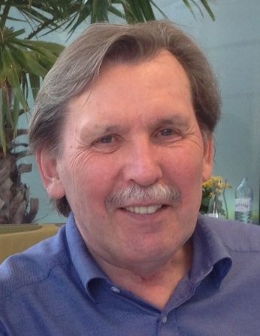
Does a Society for Gestalt Theory and its Applications still fit in our time?
This lecture presents some arguments for the view 1) that scientific “schools” still exist today, albeit often not in an explicit form, and 2) that they continue to have legitimate reasons for their existence. If certain principles are observed, the advantages of scientific “schools” as coherent systems of thought can well outweigh the disadvantages of such “schools”. For this reason the lecture argues to continue to cultivate Gestalt theory – as one among several systems of scientific thought – as a “school”, to preserve it as such and to continue to advance it in dialogue with other schools of thought, utilizing structures like the Society for Gestalt Theory and its Applications (GTA).
Contact: g.stemberger@aon.at

Kurt Guss
Co-Founder of the Society for Gestalt Theory and its Applications

40 years ago – The Foundation Period of the GTA
What was the situation when the idea arose to start the “Society for Gestalt Theory and its Applications”? The psychological landscape was dominated by the approaches of Behaviorism and Psychoanalysis. Looking for a publisher for his PhD thesis Kurt Guss met Jürgen Steinkopff, publisher in Darmstadt, and Hans-Jürgen Walter, lecturer at Klett-Cotta in Stuttgart. Steinkopff, Walter and Guss developed a plan to maintain the ideas of Max Wertheimer, Kurt Koffka, and Wolfgang Köhler by establishing an organisation which would give support to psychological research in the field of Gestalttheory. This organisation was finally founded in 1978 by Friedrich Hoeth (Dortmund), Ulrich Groeben (Darmstadt), Kurt Guss (Duisburg), Walter Piel (Dortmund), Manfred Sader (Münster), Michael Stadler (Bremen), Jürgen Steinkopff (Darmstadt) and Hans-Jürgen Walter (Stuttgart). Kurt Guss was elected Executive President and Friedrich Hoeth Vice Executive President. Wolfgang Metzger (Münster) supported the newly founded society by becoming Honorary President. Edwin Rausch (Frankfurt), Manès Sperber (Paris) and Gaetano Kanizsa (Triest) became honorary members at the very beginning. Kurt Guss shares his memories of that time, which was extremely difficult for him, and of the first and second GTA-Conventions in Darmstadt (1979) and Bielefeld (1981).

Kopernikus – an approach to the finest hour of the mind
Seafarers were the first to realise, that our perception is indeed not a true representation of reality. This fundamental differentiation between objects themselves and their appearance was devised by philosophers of Antiquity. The pre-Socratic philosopher Anaxagoras taught that the relationship is indeed the least significant part and that every movement is a motion in relation to something else, therefore a relative motion. Plato’s Allegory of the Cave clarifies the transcendent nature of experiencing real things. The study of the stars led Kopernikus to his revolutionary theory of the heliocentric conception of the world. In his honour, Immanuel Kant’s most successful achievement in the entire history of philosophy, was named “Copernican Revolution”. From the seafarers’ observations to the socratic dialogue, to Kant’s “Critique of Pure Reason” leads a logical pathway of thought to the critical realism of the Gestalt Theory of Max Wertheimer. The most important stages of this pathway are the finest hours of the mind. We can learn from the protagonists of these finest hours that there are three conditions for the development of the creative mind: Freedom, consistency and clarity. At the end of the lecture Kurt Guss links back to his lecture from 1979 at the first GTA Conference in Darmstadt by presenting a magical demonstration: the “Illusion of the stars”.

Metzger-Awards 2019

Michael W. Stadler
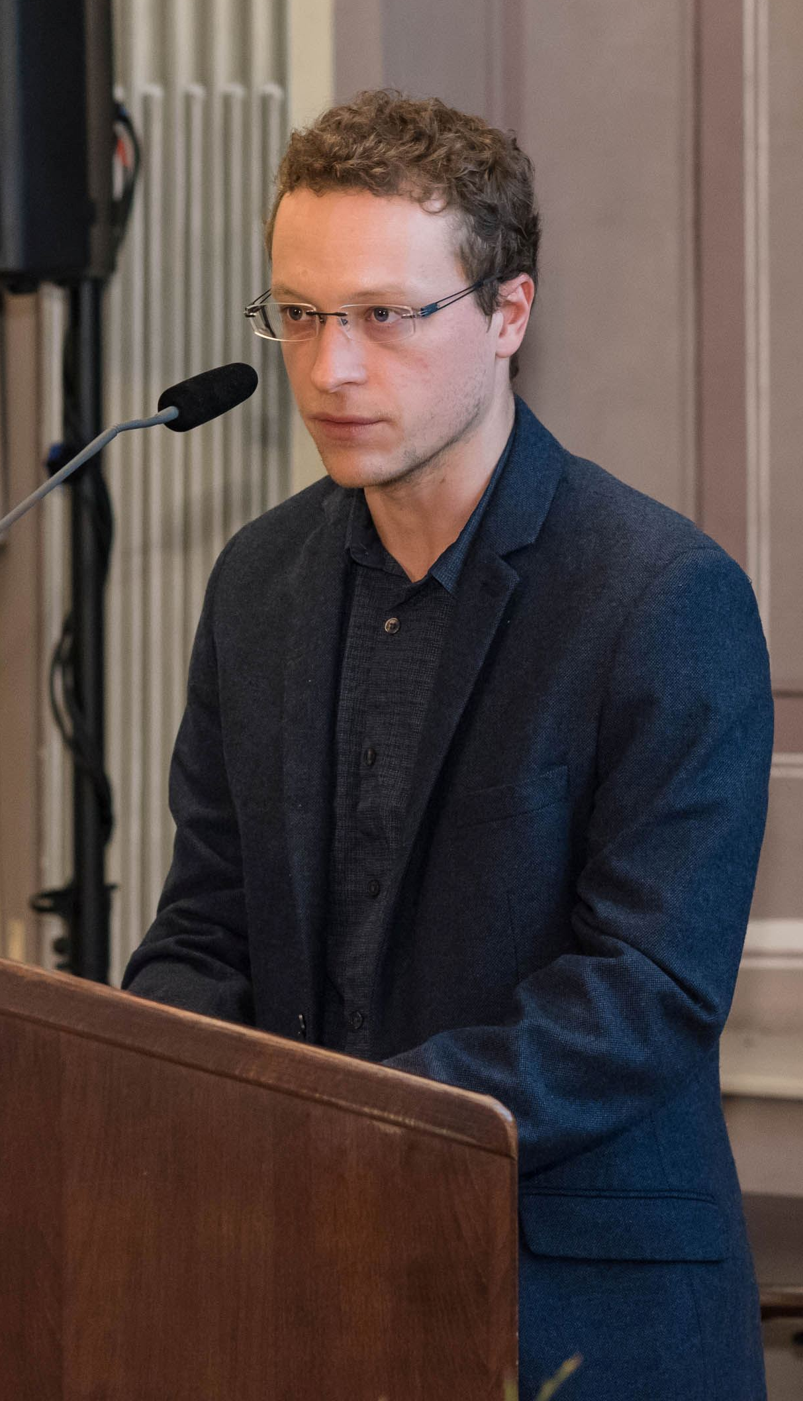
The Story of ’Mereological Interdependence’ as Embodied and Very Versatile Ontological Category
The nature of structures comprising part-whole relations belongs to the oldest, most fundamental and still discussed questions of philosophical ontology. Unlike many former approaches, which either give priority to the parts or to the whole of such structures, the present project is an ontological investigation that suggests an alternative to a hierarchical conception of parts and whole with a one-sided dependence relation. In considering the dynamic ‘in-between’ or interplay of parts and whole, I develop and determine an ontological category called ‘part-whole-oscillations’ (pwo). This development combines two crucial methodical approaches: a top-down, a priori method of formal ontology and a bottom-up recognition of empirical phenomena. By elaborating on E. Husserl’s IIIrd Logical Investigation, I show that the first method is only of restricted usefulness for the determination of pwo’s ontological nature, because it leads to formal inconsistencies. It is only in applying the second method that we can get a clearer picture of what the ontological category of pwo amounts to. This ‘empirical’ part of this project is carried out by interpreting Cognitive Linguistic’s notions of ‘conceptual metaphor’ and conceptual metonymy. It is
also carried out by critically analyzing the notion of ‘Gestalt’ as it is developed in classical and contemporary research of Gestalt theory. Through determining this category in these ways and through arguing in favor of empirical perception for the sake of ontological insights, I demonstrate that both an exclusively analytical approach towards a structure’s parts and an exclusively synthetical approach towards a structure’s whole is insufficient.This the case in particular regarding perceptually meaningful part-whole structures, and should therefore be updated with a bidirectional and more experience-based conception of interdependent parts and wholes.
Contact: michi.stadler@posteo.de

Dirk Paul Bogner
Universität Tübingen
Die Feldtheorie Kurt Lewins: Eine vergessene Metatheorie für die Erziehungswissenschaft
Kurt Lewin gilt bis heute unter Sozialpsychologen als einer der zentralen Pioniere. Sein Name ist untrennbar verbunden mit der Berliner Schule für experimentelle Psychologie und den Gestaltpsychologen Max Wertheimer, Kurt Koffka und Wolfgang Köhler, sowie Themen wie Gruppendynamik, Aktionsforschung, Motivationsforschung und insbesondere der Führungsstilforschung. Alle diese Lewin’schen Konzepte basieren letztlich auf ein und derselben Theorie, i.e der ebenfalls von Lewin begründeten Feldtheorie. Diese Theorie hat im Gegensatz zu den eben zitierten Konzepten und praktischen Anwendungen keine vergleichbare wissenschaftliche Resonanz erzeugt und kann heute als weitestgehend vergessen bezeichnet werden. Im wissenschaftlichen Diskurs spielt sie keine nennenswerte Rolle mehr. Dies gilt wohlgemerkt für die Sozialpsychologie. Für die Erziehungswissenschaft kann ein noch viel drastischeres Bild gezeichnet werden: Hier spielte die Lewin‘sche Feldtheorie noch nie eine nennenswerte Rolle und Kurt Lewin wird meist reduziert auf seine für die Klassenführung relevante Führungsstilforschung. Dies ist ein großes Manko, so die in dieser Arbeit vertretene These, denn Lewin ermöglicht mit seiner Feldtheorie auch heute noch eine völlige neue Sicht auf Lern-, Entwicklungs- und Erziehungsprozesse zu schauen und diese systematisch zu analysieren. In diesem Sinne stellt die hier vorliegende Arbeit den Versuch dar, Kurt Lewins Feldtheorie in die Erziehungswissenschaft einzuführen und am Beispiel der Pädagogischen Diagnostik Grundzüge der praktischen Möglichkeiten aufzuzeigen. Insgesamt betrachtet, ist die Arbeit in drei eigenständige Teile gegliedert. In einem ersten Teil wird die Feldtheorie in ihrer Genese und Systematik rekonstruiert. In einem zweiten Teil wird untersucht, warum die Feldtheorie von der Erziehungswissenschaft ihrer Zeit ignoriert wurde und in einem dritten Teil wird exemplarisch am Beispiel der pädagogischen Diagnostik aufgezeigt, wie die Lewin‘sche Feldtheorie heute im schulischen Kontext Anwendung finden könnte.
Contact: dirk.bogner@uni-tuebingen.de

Lecturers

Mauro Antonelli
University of Milan

Vittorio Benussi and “Emotional Functional Autonomy”. Replication and Re-evaluation
The talk presents a study which takes up, replicates and re-evaluates the research on the functional emotional autonomy developed by Vittorio Benussi in Padua in the 1920s, using hypnosuggestive methods. Four fundamental emotions of human experience were studied in hypnosis: hope, happiness, despair and unhappiness; the measured physiological variables were breathing and skin conductance. The study found that there is a specific respiratory profile for each of the emotions examined, thus confirming the results obtained by Benussi and opening the way to the existence of a “physiological unconscious”, which would consist of specific patterns of physiological responses triggered by specific, pure emotional states.
Contact: mauro.antonelli@unimib.it

Natalia Artemenko
University of St Petersburg
Thematisation of Passivity in Husserl’s Phenomenology and the Problem of the Intersubjective World.
The problem of passive constitution in E. Husserl’s phenomenology is worthy of being put emphasis on, since passive constitution, contrasted with active conscious constitution, should be reckoned among the focal points of philosophy of the 20th century. The questions posed by Husserl still represent the topical issues of the philosophical thought. Husserl’s phenomenological studies are currently generating strong interest among the realms of cognitive theory and neurobiology, psychology and psychiatry as well. The problem of passive synthesis is closely related to the distinction between the static and genetic methods of research, the theme of lifeworld and corporeality. Thematisation of the sphere of passivity is related to solving the problem of intersubjectivity. According to our operational theory, it was the demand for thematisation of the genesis of the sense of “the Other” that largely influenced the modification of the phenomenological method. The report will be devoted to contemplating of passive constitution in the works of the late Husserl as well as to the link between this topic and a topic of intersubjectivity. We will elaborate upon the history of consideration given to the problem of intersubjectivity by Husserl, in order to clarify the way the attempts of solving the problem of intersubjectivity, based on activity of the Self, led to an egocentric model, and, in its turn, the demand for overcoming such model led to thematisation of the genesis of subjectivity and the detection of passivity as the very basis of such genesis.
Contact: n.a.artemenko@gmail.com

Rafał Augustyn
Maria Curie-Skłodowska University in Lublin

Expressing motion in multimodal film setting
The paper analyses different dimensions of motion coded visually, audio-visually and verbally, as represented in two science-fiction films Arrival (2016) and Blade Runner 2049 (2017) directed by Denis Villeneuve. The focus of this paper is on how cognitive linguistics tools (such as embodiment, image schemas, metaphor, metonymy and blending) can explain the ways in which certain aspects of meaning emerge holistically in multimodal film setting, where image appears to be the dominant mode of presentation, supported by other modalities, including the verbal (dialogues or written language) and auditory inputs (sound and music composed for the film). Given that the latter two modalities are used either as prominent or liminally ostensive stimuli in the examined films, while the image is relatively static, the paper examines selected examples of how these three modalities (visual, auditory, verbal) interact to create a cognitively coherent impression of dynamic motion in the analysed science-fiction dramas. The methodology applied in this study combines the elements of cognitive film analysis (cf. Bordwell 1989; Thompson 1999; Coëgnarts & Kravanja 2012, 2015; Coëgnarts 2017) with cognitive linguistic tools, focusing in particular on multimodal metaphor (Forceville 2016; Forceville & Urios-Aparisi 2009) and conceptual blending (Fauconnier and Turner 2002; Oakley & Coulson 2008; Brandt 2013).
Contact: rafal.augustyn@poczta.umcs.lublin.pl

Giulio Baldassi
University of Trieste
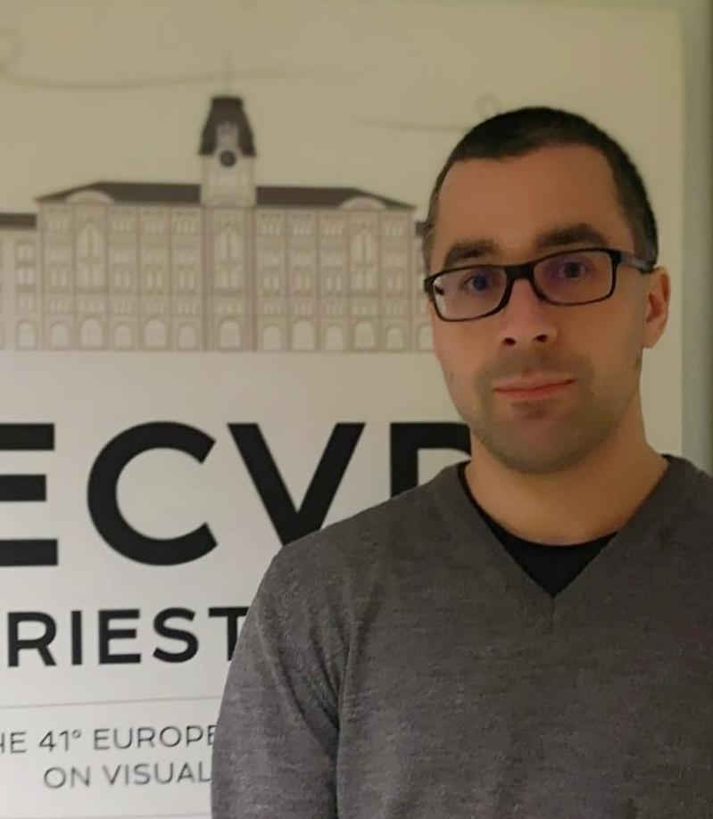
Ecological sounds are more effective than artificial sounds in breath modulation
Co-authors: Giulio Baldassi, Ilaria Santoro, Serena Mingolo, Mauro Murgia, Tiziano Agostini
Artificial and ecological auditory cues can modulate movement as well as physiological parameters. In the present study, we compared the effects of ecological and artificial auditory cues on breath duration. Our results seem to confirm that ecological sounds capture the timing of breath duration better than artificial sounds, guiding therefore participants’ breathing.
Contact: GIULIO.BALDASSI@phd.units.it

Jacqueline Bellon
University Siegen


Grund, Figur und Grenzübergänge als Bewegungsmotoren
With Gilbert Simondon „motion“ can be captured as a process of leaps from one metastable state to another in which motion stays possible if and only if there still is „potential“ left in a system – meaning that the system has not yet reached a stable state. In this talk I want to highlight the ways in which Simondon relates this thought to the distinction between figure and ground as a motor to all motion processes. I will furthermore shortly outline how Simondon frames the “outer and the inner world” within a theory on individuation, thereby making it possible to describe individuation as a motion process that can be found similarly in individual and collective processes as well as in psychological, physiological and physical processes.
Contact: Jacqueline.Bellon@uni-siegen.de
Alfonsina Buoniconto
University of Salerno

Intratypological and intertypological variation in motion events encoding. A diachronic account from three Romance varieties
In recent years, the ground-breaking typological classification of motion events encoding set forth by Talmy has received many revisions, which have led to the definition of a non-dichotomic typology described in terms of constructional and semantic clines. Such an approach perfectly applies to the description of Romance languages (more specifically, Italian, French, and Spanish), which, thanks to a corpus-based data analysis carried out on parallel texts from three different time stages, were proven to feature at least 17 types of motion event expressing constructions, that can be arranged along a typological continuum ordered according to a synthetic/analytic/synthetic pattern.
Contact: abuoniconto@unisa.it

Irene Candelieri
University of Trieste



Sound, dance and motion in Franz Boas’s field research in British Columbia
In a letter sent to Erich Moritz von Hornbostel on 3th August 1920, Franz Boas - widely regarded as the founder of American cultural anthropology and one of the pioneer of ethnomusicological studies - answered to the director of the Berlin Phonogramm Archiv about the “problem of variability in motor habits and gesture language of different races” and his effort “to direct the attention of psychologists to it”. Consistent with his epistemological cultural relativism, Boas conducted field work in the Pacific Northwest Coast between 1885 and 1930 with a holistic approach, pioneering the use of recordings in sounds, social and religious dance performance among the Kwakiutl, Bella Coola and Thompson River Indians. Focusing on cultural immaterial objects, as language, music, dance, sequences of behaviour, life group displays (dioramas), Boas highlighted the importance of holistic perception in dance, language, music: in this view, he seemed to be in tune with Hornbostel’s considerations about the unity of the senses and the arts in Die Einheit der Sinne (1927). Besides, he underscored the rhythm as a common element for the abovementioned cultural phenomena: according to boasian ritual analysis, “with its percussion music is completed and the act of creation between dance and music realized. Such a realization will eventually carry its message to the audience.” Toward the end of his career Boas continued the study of relationship between music and dance, recording Kwakiutl dance and gesture in collaboration with his daughter Fransizka. She later explored dance as a holistic practice and the idea that movement could initiate emotional healing, by working at Bellevue Hospital in New York from 1939 until 1943 with the child psychiatrist Lauretta Bender (the developer in 1938 of the Bender Visual-Motor Gestalt Test).
Contact: irenecandelieri@gmail.com

Elena Capitani
University of Macerata
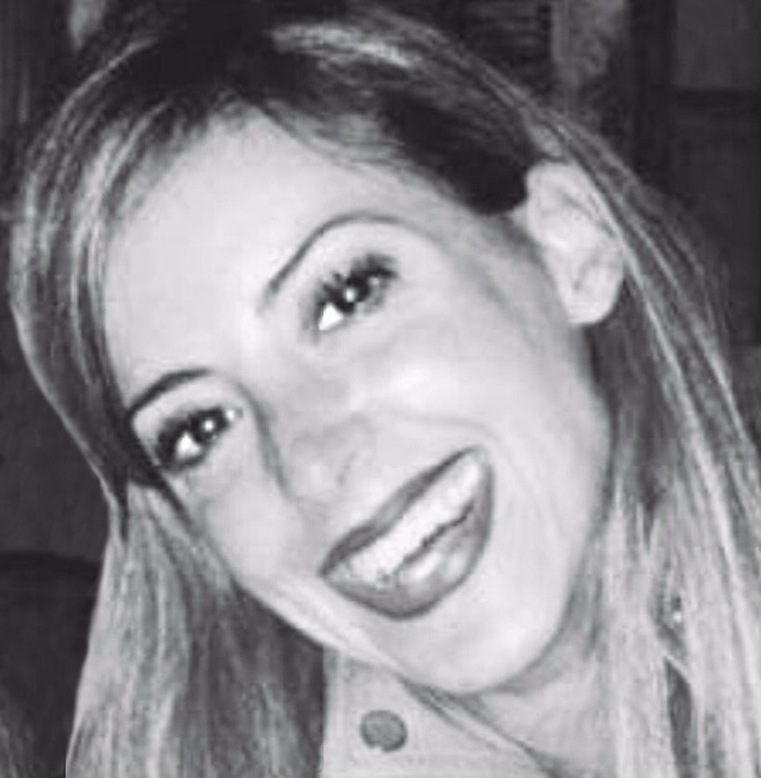
What is the opposite of a process? The spontaneous meaning of opposite in represented spatial processes
Co-authors: Ivana Bianchi, Erika Branchini, Roberto Burro
Two Tests of Relational Reasoning, one graphical and one verbal (TORR and vTORR; Alexander et al., 2015, 2016), were developed to measure people's ability to reason by means of opposites. Studies in perception have shown that both the spontaneous production and recognition of an opposite figure require the global identity of the original figure to be maintained while its direction is inverted (Bianchi & Savardi, 2008). A study was conducted in order to verify whether these criteria were present both in our participants' spontaneous production of one or more grafical processes opposite to the target stimuli presented (which we selected from the TORR) and in the corresponding correct answer (according to the TORR).
Contact: capitanielena84@gmail.com

Serena Cataruzza & Walter Coppola
University of Trieste
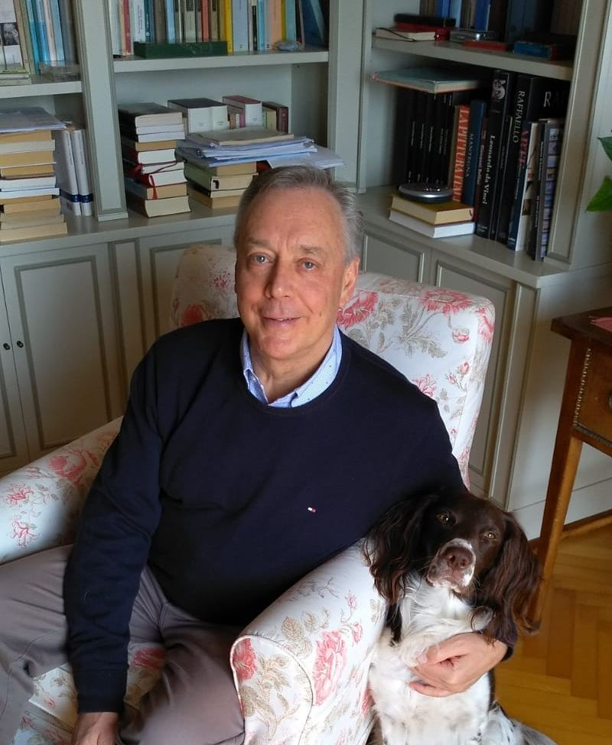
Gestalt and movement between music and dance
Co-author: Walter Coppola
The famous essay by Christian Von Ehrenfels, Über Gestaltqualitäten (1890) opens up, as is well-known, an important seam not only in the psychology of perception but also of aesthetics, of the psychology and philosophy of music, art and language. Here, in fact, the form understood as “Gestalt” is something concretely audible and visible and not simply a formal abstraction. It is about a pioneering program rich in ideas and original connections. The author does not mean simply to define the meaning of the concept of Gestalt, but also sets out a fertile variety of extraordinary applications. In the first place – following a suggestion of Ernst Mach’s – he indicates an application in the field of music, in particular in the exemplary case of melody. Melody is perceived as a unity of a new kind (not simply summative) through the succession of sounds. These are necessary but not sufficient in themselves, since melody as a “gestalt quality” can be made with different sounds by transposing that melody to a different scale. As will later be said: “The whole is different from the sum of its parts”. It is clear that the author gives importance to the connection, to the relation between the parts, and therefore to the interval between the notes as regards the content of the individual note. Hence the following subject: what does it mean to recognise, to remember a melody? It is important to remember the Gestalt as a succession of sounds and not as the sum of individual sounds. In this sense the melody, as a temporal Gestalt, is a more fitting illustration of Gestalt than a spatial Gestalt (e.g. of a geometric figure). But in other cases, as for instance in the case of perception of movement, both temporal and spatial Gestalts are admitted. And a characteristic example is provided by dance. Here each movement possesses an expressive quality: a fluid movement, broad, leaping, circular, and so on. However, it is not stated that the gestalt quality has the same characteristics in every sensory field: according to Ehrenfels the acoustic-melodic Gestalt, with its succession of sounds, can be more easily recalled to memory than the dancing Gestalt, with its succession of steps. In this essay we shall investigate the comparison between sound movement and visual-gestural movement, and we shall also be discussing the matter by having recourse to the experience of professional dancers.
Contact: serenacattaruzza@alice.it, walter.coppola@alice.it

Chiara de Vita
University of Trieste

Karl Bühler’s fantasmatic deixis between motion, gestures, and words
What is the “fantasmatic deixis”? It is a very creative and productive cognitive-linguistic operation that allows a “transfer” in other real or fantastic times, places, and “worlds”. The underlying psychological question concerns the possibility of moving and being moved with respect to something or someone who is absent (Bühler, 1965). This “fiction game” is made possible by deictic indicators, terms that allow motion in time and space, always considering the here-now-I system of subjective orientation. When we refer to something that can be gathered by hearing or by sight, by terms such as here, there, I, you, the receiver can easily use natural, prelinguistic aids (e.g., gestures, voice quality, facial expressions, body orientation) to understand what the issuer intends to communicate to him (demonstratio ad oculos). But what happens when we move from the study of “immediate” behavior to that of “mediate” behavior, that is of the field of memories (retrospection) or the constructive fantasy (prospecting)? The fantasmatic deixis implies an enfranchisement from the physical position of the body and requires the assumption of the listener’s current tactile body image. Thus, the receiver assumes an inner attitude to correctly interpret the indications given by the speaker, seeing and hearing through the “inner” or “mental” eye and hear (Raynaud, 2006). In this way, the listener can bring something absent in his here, now, I or feel moved to the point where the speaker leads him. The presentation will focus on the features and types of fantasmatic deixis, providing some examples and showing how this operation involves both language, motion, and cognitive processes
Contact: chiaradv@hotmail.it

Olha Dunaievska
Taras Shevchenko National University of Kyiv


Godfather: motionless gains motion
Co-author: Taras Schevchenko
Gestalt linguistics provides an opportunity to get deeper into cognitive processes of language mechanisms. Interdiscursive representations of investigated “BAPTISM”-gestalt illustrate the motion of its nominative space. Lexical unit godfather depicts the diverse motion of “BAPTISM” nominative space.
Contact: o.dunayevska@gmail.com

Herbert Fitzek
Business School Berlin

ART moves MIND moves ART
The Moses of Michelangelo and the Gestaltkreis of Art Reception
According to Gestalt Theory the impact of arts is not adequately described as a transfer of an artist’s message into a recipient’s state of mind. As a matter of fact (and effect) art represents complex fields of meaning (figurations) rooting in the specific conditions of art creation and proceeding to the concrete effects of art reception. From a psychological point of view artefacts cannot be reduced to static objects, nor are the recipients passive spectators of the scene. Aesthetical experience is an action field from which the material of art and its reception emerge. In my contribution the relationship of subject and object in art is modelled in terms of Victor von Weizsäcker’s Gestaltkreis of perception and action. For this purpose, I will refer to the favourite subject of art coaching: the Moses of Michelangelo in Rome.
Contact: herbert.fitzek@businessschool-berlin.de

Maria Gołębiewska
Polish Academy of Sciences
The Performative Aspects of Metaphor – between Intentionality and Conventionality
As is known, metaphor has been considered an expression of the creative approach of a subject to language and thinking. Starting with Aristotle and his studies dedicated to metaphor (particularly, metaphor as a „transference of sense” from a word or a group of words, to a different utterance), it was treated as a linguistic instrument of moving and the dynamisation of thinking, often linked with the works of imagination. Similar to Paul Ricoeur and his studies regarding metaphorical semiosis and phenomenalisation, the contemporary researches consider the individual and arbitrary creation of metaphors in everyday life, as well as, the openness of metaphor towards interpretation. Metaphor enables the subject of cognition and action to establish meaning – the subject exercises semiosis not only by referring to the former convention and the situational context, but also transforms it due to the distinct act of turning the metaphor in an instrument of own expression. The innovative character of metaphor allows to consider it in the context of performative studies, whereas, its receptive, evocative character requires interpretation from the recipient. The dynamisation of thinking, accomplished due to the work of metaphor, and its „moving” considered within the frameworks of the performative theory, are the subject-matter of the paper. The basic question of the paper, referring to Austin’s speech act theory and to his followers, is related to the source of the aforementioned dynamisation – to what degree is it an intention of language users, and to what degree is it a language convention which allows to combine words and establish new associations metaphorically?
Contact: mgolebie@ifispan.waw.pl

Andrea Lanza
University of Florence / IFISPan



Kinesthetic unity as motivated association
Within the theory of Husserl’s perception, the role attributed to the kinesthetic sensations comes to determine a phase of the perceptive constitution that marks the boundary between pure receptivity and a first form of self-determination of consciousness. The kinesthetic experiences are characterized, in fact, not just as acts that are performed but rather that can be performed, albeit according to predetermined paths.
This primitive form of “instinctive” spontaneity of the ego (linked to primal impulses), as the realization of pre-established potentialities, characterizes what Husserl defines as the “idiopsychic” dimension of consciousness (HUA IV, p. 135). Although presupposing a spontaneous activity, this level of consciousness unity can be investigated according to the “causal” laws of motivation.
The phenomenon of motivation was notoriously introduced by Husserl in § 56 of Ideen II, as a specific law of spiritual life. However, there are two possible forms of motivation, one in which the ego is actively involved, and the second one, called “associative motivation”. It basically indicates the passive tendency of creating associations between unities of the immanent sphere. In other terms, Husserl acknowledges the existence of “motivated relations” within the immanent sphere of mental acts which do not necessarily call for an active participation of the ego. In this sense, the relation between motivating factors and motivated elements could be considered a kind of conditioning of the form “because-therefore”, in which the two elements arrange themselves in a succession of experiences. This work aims to show that this very type of association is the same that pre-determines the unfolding possibility of kinesthetic chains.
Contact: andrea.lanza@unifi.it

Anna Michalska
Polish Academy of Sciences
Motion and intersubjectivity
The point of departure of the presentation is Wolfgang Köhler’s principle (1947), according to which our cognitive systems develop, on both ontogenetic and evolutionary levels, through progressive differentiation, which is counteracted by a growing capacity for integration (or unification). Both of these forces, when working in tandem, cause a general increase in the complexity of the individual cognitive structure as well as of human “life-form” in general. My aim is to show that this principle can be productively applied to the problem of intersubjectivity. I intend to demonstrate that object cognition and social cognition are two sides of the same thing, namely, of exploratory – in contrast to exploitative – behaviors. The differentiation–integration dynamics has been explicated or presupposed in many a psychological conceptions of self-differentiation (e.g. Bowen&Kern 1988) and dialogicality inherent in the self (Hermans&DiMaggio 2004). Essentially, it is assumed here that in order to understand another one must be able to identify and understand one’s alter-egos. In the process, a space is created which comprises and integrates different possible outlooks on the same problem-situation. On this account, cognition hinges on the capacity to skillfully navigate such spaces, which permits one to resolve both internal and external conflicts and deal with inevitable power struggles. Contact: michalskanna@gmail.com

Serena Mingolo
University of Trieste

Co-authors: Giulio Baldassi (University of Trieste), Tiziano Agostini (University of Trieste), Mauro Murgia (University of Trieste), Eleonora Bilotta (University of Calabria)
The perception of temporal deviations in tap dance: The role of experience and modality
It is well-known that the auditory modality dominates the visual modality in processing temporal information of simple stimuli, and that experts outperform non-experts in biological motion perception. In the present study, we investigated how experts and non-experts detected temporal deviations in tap dance sequences, in the auditory modality compared to the visual modality. We found that temporal deviations were better detected in the auditory modality compared to the visual modality, and by experts compared to non-experts.
Contact: mingolo.serena@gmail.com

Christopher Mitchell
Université Grenoble Alpes France (UGA)

Moving towards appropriate prosody
Co-author: Anda Fournel
There is little resemblance between the dynamic exploration associated with the acquisition of the mother tongue and the learning of a second language. The latter is more static, with the focus on reading, writing and listening comprehension. The importance of the sensorimotor experience in language learning has until now been associated with vocabulary acquisition, focusing on the use of gesture. Its essential role in oral production in general, and prosody in particular, has been neglected. (Aronsson, 2014). However, appropriate prosody is recognized as being essential to intelligibility and comprehension. (Kjellin 1999, Wells et al, 2008,) Our group* has brought together artists and researchers in cognitive sciences to explore the role of the interaction of the body in movement with the space in which it finds itself, and with the body of the other, in pursuit of improved prosody. Our approach makes prosody more accessible and ‘teachable’ through its focus on corporal and vocal awareness as perceived from within. (Mitchell et al, 2018). Through two praxes, the Silent Experience and the Engaged Body, we examine what is happening within the body prior to the speech act, as well as during it, and how the body interacts with the space and the other. Movement, on- the-spot and in spatial expansion, is combined with feeling and emotion to reconnect the body with a sensory awareness of language. The resulting whole-body voice is the key to the improved prosody which is the aim of our research work. By questioning the perception of the body's place in teaching oral production, we support teachers in the task of integrating sensory-motor experience into classroom practice.
*Innovalangues THEMPPO UGA, France
Contact: christopher.mitchell@univ-grenoble-alpes.fr

Mitchell Atkinson III
Polish Academy of Science, IFISPan

Spaces of Possibility and their Spontaneous Sonic Exploration: Toward a Phenomenology of Improvised Music
It is commonly held that writing about music, both musical artifacts (songs, recordings, etc.) and the experience of playing music, is difficult. Of the forms of musical activity, improvised music presents itself as the least amenable to conceptual or philosophical analysis. In the following paper, I employ the tools of phenomenology to develop a concept of improvisational work as spontaneous exploration of predetermined possibility spaces. In so doing, I introduce and expand upon my own notion of possibility spaces and their application as necessary preconditions for an exceedingly broad range perceptual act and social interaction. The multidimensionality of improvisational work is discussed as meaning production along several simultaneous “vectors” of meaning. A historical development of improvisational work in the American Jazz context is discussed with the aim of shedding light on how functional topologies within possibility spaces change over time as a feature of social movement. The link between such topological shifts and the advent of free-thinking “talent” (and their attendant innovations) is discussed as well as the nature of “free thinking” as such. Finally, I argue that phenomenology of music is properly conceived as phenomenology of the body and discuss consequences for viewing all musical work as work of the voice.
Contact: atkinson.mitchell@gmail.com

Mauro Murgia
University of Trieste
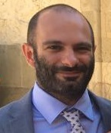
Rhythmic auditory stimulation and gait rehabilitation in Parkinson’s disease: artificial versus ecological cues
The individuals with Parkinson’s Disease (PD) typically have gait disturbances and impaired timing mechanisms (Murgia et al., 2015; Nombela et al., 2013). Previous studies demonstrated the efficacy of rhythmic auditory stimulation (RAS) for the gait rehabilitation of patients with Parkinson’s disease (Thaut et al., 1996). The RAS consists of an isochronous sequence of beats (usually metronome or music-based sounds), however no study investigated the effects of ecological footstep sounds. In this study we compared the effects of a rehabilitation program integrated either with ecological or with artificial RAS, namely using metronome or footstep sounds. Thirty-two participants were randomly assigned to one of the two RAS conditions. We investigated the effects of 5 weeks of supervised rehabilitation integrated with RAS, assessing the participants before the training, at the end of the training, and three months after its end. We measured the spatio-temporal parameters of gait and some clinical variables. The results showed that both groups significantly improved in the majority of variables, independently of the type of sound. Analyzing the data separately, the improvements on spatio-temporal parameters of gait emerged only in the ecological RAS group. Overall, our results suggest that rehabilitation integrated with ecological RAS is as effective as that integrated with artificial RAS. However, the separate group analyses suggest that the richness of ecological stimuli might have a superior effect, which should be further investigated.
Contact: mauromurgia82@gmail.com

Giulia Parovel
University of Siena

Comic aftereffects of incongruent causal contingencies
Co-author: Niccolò Mencucci
Even simple geometrical shapes, since Heider & Simmel’s demonstration (1944) and Michotte’s work (1946/1963), despite their inanimate character, can express aliveness, emotions and intentional attributes by virtue of their motion. According to Michotte the perception of meaning is intrinsically related to the functional connections between moving objects, and we can directly “live” it. In recent years, there have been a wide range of experimental results related to the perception of causality and animacy from motion cues, which have given a strong psychophysical and neurophysiological support to this view, demonstrating that the impression of aliveness and meaningfulness of these events is surprisingly vivid, immediate and compelling and that they are strongly related to low-level visual processing (Scholl & Gao, 2013). We report an aftereffect of phenomenal causality, according to which specific spatiotemporal configurations, obtained by manipulating perceptual causality and animacy to get incongruent causal contingencies, can genuinely trigger comic impressions (Parovel & Guidi, 2015). The main experimental findings are coherent with the Bergsonian perspective and with incongruity theories. We also propose that many classic gags of visual comedy, as the ones we can appreciate in Buster Keaton films, can be insightfully read as incongruent causal contingencies, where (casually) temporally close events are perceptually grouped in causally related comic events.
Contact: giulia.parovel@unisi.it

Joanna Pędzisz
Maria Curie-Skłodowska University in Lublin
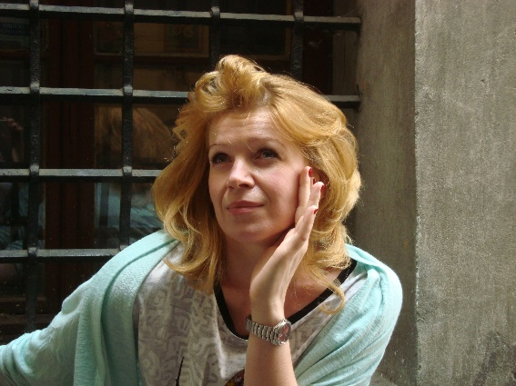
„Jede Bewegung verläuft in der Zeit und hat ein Ziel“ (Aristoteles). Zum interdisziplinären Blick auf den Diskurs der zeitgenössichen Tänzer
Will man inter- bzw. transdisziplinär vorgehen, bietet der Diskurs der zeitgenössischen Tänzer als Forschungsgegenstand einen idealen Ausgangspunkt für. Da sich der Tanz an der Schnittstelle zwischen Körper und Intellekt, Geist und Seele befindet (vgl. Gierz), sollten auch solche Forschungsfragen aufgegriffen werden, die die Versprachlichung eines Tanzereignisses in den Blick nehmen und sie auf die Forschungsbereiche wie Tanzwissenschaft, Bewegungswissenschaft, Gesprächsanalyse, Diskursanalyse und Kognitive Linguistik beziehen. Die in dem Vortrag erörterten Forschungsfragen richten den Fokus auf a) die Kennzeichnung der Körper- und Bewegungskonzepte, b) die zeitgenössischen Tänzer als Diskursgemeinschaft, c) die während der Tanzlernprozesse realisierten Sprechakte, damit verfolgten Absichten der zeitgenössischen Tänzer, und d) die Konstruierung der Bedeutungen im Prozess der Versprachlichung eines Tanzereignisses. Die Auseinandersetzung mit der Fragestellung kann darauf abzielen, die funktionslinguistisch relevanten Kategorien der Intention und Motivation der sprachlich handelnden Tänzer zu eruieren und dadurch den Diskurs der zeitgenössischen Tänzer zu präsentieren, mit dem die Grenze der Sprachwissenschaft überschritten werden kann.
Contact: joanna.pedzisz@gmail.com

Savina Raynaud
Università del Sacro Cuore, Milan
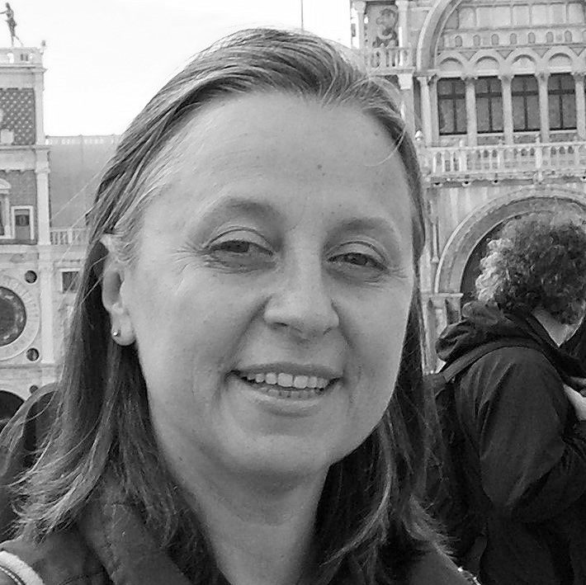
Moving Words
With the proposed title, which plays on the ambiguity and the word order proper of the English language, I wish to suggest a double reading direction: ‘words’ as both the head of a noun phrase and as the complementary object of its preceding predicate. In other words, in my talk I will focus on the role of word order (Wortstellung) in shaping and moving the addressee’s thoughts and passions. In doing so, I will highlight the attention paid to syntax from a semantic-pragmatic point of view, firstly in the philosophy of language developed within the Brentanian school, especially by Anton Marty, and subsequently in Prague Linguistics, throughout the 20th century, beginning with the founder of the Prague Linguistic Circle, Vilém Mathesius, up until the Communicative Dynamism Model of the Brno School, which was developed by Jan Firbas and still flourishes from both a theoretical and an applied perspective. The main topic will be the more or less free processes of textual and sentence linearization on the speaker’s side, and the corresponding non-symmetrical processes of global comprehension on the addressee’s side. In Marty we shall dwell on both figurative and constructive inner linguistic form. In Mathesius we will consider the theoretical development from the first contrastive studies on Czech and English word order and ellipsis up to the so-called Prague Functional Sentence Perspective. In Firbas we will observe further categories beyond theme and rheme. Finally we will focus on commotion, emotions and the action leading dimension of speech act.
Contact: savina.raynaud@unicatt.it

Taddio, Luca
University of Udine
Merleau-Ponty: From the Psychology of Gestalt, to the Analysis of Movement and Cinema
Co-author: Damiano Cantone
With this paper we intend to investigate the reflections Merleau-Ponty develops—in particular in his 1953 course, Le monde sensible et le monde de l’expression—on the analysis of the ‘apparent movement,’ taking into account some experiments he retrieves from Gestalt Psychology as, for example, the stroboscopic movement, and the experiments of Gelb, Michotte and Ternus, which orient his engagement with the topics of identity and movement. In Merleau-Ponty’s 1953 class, the ‘bodly’ expression is understood qua ‘movement’ and the movement qua “révélateur de l'être.” Following this theoretical perspective, I will investigate whether the ‘apparent movement’ is only an ‘apparent’ phenomenon or it can rather be interpreted in an ‘ontological’ way. I want thus to ask to what extent the ‘apparent movement’ is connected with our ‘body’ and, if so, what are the consequences to be drawn from an epistemological, ontological and aesthetic point of view (in particular, with respect to cinema). Concerning ‘cinema,’ montage will be examined, as a technique showing the possibility of overcoming the subjective point of view of a ‘single person,’ gearing towards a synchronization of all the possible glances, thus reconfiguring the issue of identity.
Contact: luca.taddio@uniud.it

Maciej Talaga
University of Warsaw
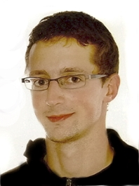

Archaeology of movement. Historical records and modern bodies as media for investigating past embodiment
Somatic skills are embodied knowledge and as such can be preserved through direct interpersonal transmission (mimesis) or indirect media (notations of motion). Reading historical notations of motion when the lineage of direct transmission is broken poses serious methodological challenges leading to narrativists’ and constructivists’ conclusion that actual reconstruction of their contents is impossible. However, I posit that through a methodical combination of text-based studies and practical experimentation (embodied research) these difficulties may be overcome – motion reconstruction based on a European medieval martial arts treatise will serve as a case study.
Contact: maciektalaga@gmail.com

Maria Paola Tenchini
University of Brescia
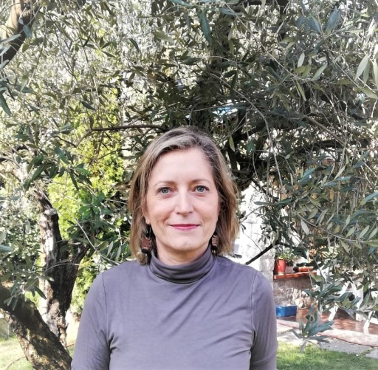

Words in Motion: Slurs in Indirect Reports
Slurs are pejorative epithets that derogate a whole category of individuals, although they usually have a specific individual as target. In fact, they derogate the individual on the basis of some property she shares with other individuals: color of the skin, ethnicity, sexual orientation, religious beliefs, etc. Some examples of such pejorative expressions are: “nigger”, “kike”, “faggot” etc. Literature on slurs is vast and often located at the intersection of different disciplines. In Frigerio & Tenchini (2014), we have sketched out a map of the main different theoretical positions on the semantic status of the derogatory content of slurs. The various approaches treat differently the case of slurs in indirect reports: here the core question concerns the attribution of the responsibility for the act of slurring. Does the reporting speaker of an utterance containing a slur derogate the target group by means of her act? On one hand, the answer may be she does not: one can claim that the reporting speaker is simply attributing the derogation to the reported one (this is at least one of the possible interpretations). On the other, in many cases the reporting speaker avoids mentioning slurs in quotations or indirect reports in order to avoid the danger to be charged with the derogatory content , or, when quoting, she often adopts contextual strategies in order to charge the reported speaker with the slurring act. These precautions show that, although the reporting context seems to be the most favorable to push the derogatory content into the scope of the reporting operator, this operation is neither simple nor natural. The aim of my contribution is to examine how slurs work in indirect reports.
Contact: paola.tenchini@unicatt.it

Reinhold Utri
Warsaw University

Mens sana in corpore sano – Learning and Movement. Effects of physical movement before and during the learning process
We will try to prove or to disprove the old Latin saying. We all can imagine scientists, very good scientists who sit all day long and get to great scientific results. On the other hand in every classroom there are pupils/ students who love movement and sports (even running through the classroom during a class) and have not much success in school subjects. There are some new insights and experiences of the effect of movement on learning progress, of teaching hyperactive kids (kids that are of the movement type, often they are called the difficult ones because of the lack of having a possibility to move during class they disturb it) and of teaching including (some) movements. Psycholinguists like Manfred Spitzer and psychologists like Ulrike Cress and Hans-Christoph Nürk support the slogan „school in motion“ – the fact that physical health is also beneficial to cognitive functions.
Contact: r.utri@uw.edu.pl

Alicja Waszkiewicz-Raviv
Warsaw University

Gestalt Public Relations. Perception laws as sequencing theory for organizational communication activities.
The paper will present the adjacency of Gestalt principles in public relations theory. The heritage of Gestalt theory thoroughly described by Wagemans et al (2012) remains largely ignored in contemporary public relations research that is increasingly interested in visual aspects of relationship building communication activities (Collister, Roberts-Bowman, 2018). The paper will attempt to bring together the potential in research and practice of both scientific fields. The tools of visual PR will be attributed to each Gestalt principle. Perception do not rely only and directly on the information present in the stimulus. Recipients’ interaction with visuals is dynamic (Holsanova, 2014). Perception leading to cognitive activation that might end up with understanding PR message, has two ways: bottom-up and top-down. Fiske and Taylor (2013) call the first one the data- driven process, as the shaping of abstract representation in the mind is rooted mainly in the external stimulus e.g. initial communication campaign of new organization in the new market segment. The top-down way however is organized by category-driven processes, means perception is mediated by already existing cognitive schemes and on the stage of receiving stimulus it’s already a constructive process, as what we see in any given visual image always has a context. It’s the PR dialogue, not marketing action, that provides the cognitive frame for publics. “Our perceptions of the world reflect an interplay between what’s out there and what we bring to it” (Fiske and Taylor, 2013:112).The constructivist approach stresses the role of knowledge in perception and therefore is against the simplistic nativist approach to perceptual activity. It allows behaviour to be generally appropriate also to non-sensed object characteristics, like optical distortions, things that appear to be “real” but are only cognitive delusions. The publics remaining in the dialogue with organization, with time learn specific aesthetics (e.g. Disney corporation) and starts to pay attention to specific institutional visual stimuli, like logo or CI typography. PR encompasses constant researching, conducting and evaluating communication programs to achieve the informed public understanding necessary to the success of an organization’s aims. PR adapts, PR is in the move along with its publics. Nowadays, it uses visual, interactive media as one of main channels to reach the recipients in their constant flow. PR essence is based on closure mechanism that engages stakeholders’ cognition but in less direct way, in contrast to marketing. When visual objects look similar to one another, people often perceive them as a group or pattern. PR theory often advocates for integration between communication channels in order to have stronger impact and create impression of unity. Rather than seeing separate communication lines and angles, the singularly executed programmes are to be comprehended as belonging together and shaping ongoing dialogue, the good continuation. The PR action is always conducted with the strong relation to the context, the organizational environment. In the presence of contemporary media noise (the ground), it’s the goal of PR coherent messages to be the figure, and by that one may assess, whether the PR agenda stands out appropriately or blurs. And finally, proximity indicates that items (organization and its publics) are connected or have a relationship with each other. Such unity helps to organize and gives structure to the communicative performance. Contemporary perceptual experiences of the media users might be explained through the of Gestalt lenses (see also Poulaki, 2018). When organization conducts PR strategically, it may influence the way people perceive reality.
Contact: alicja.waszkiewicz@uw.edu.pl

Workshops

Workshop 1:
Essentials of Gestalt Theoretical Psychotherapy: Guiding principles for the therapeutic relationship and practice of Gestalt Theoretical Psychotherapy

Part I: Foundations of Gestalt Theoretical Psychotherapy

Katharina Sternek
Gestalt Theoretical Psychotherapy (Vienna) / ÖAGP
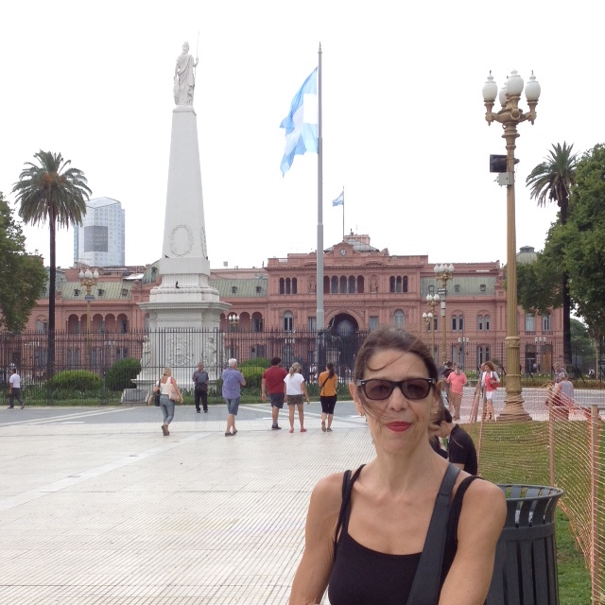
Essentials of Gestalt Theoretical Psychotherapy: Critical Realism: The Epistemic Position of Gestalt Theoretical Psychotherapy
An essential peculiarity of Gestalt Theoretical Psychotherapy is its insistence that therapists are guided in their work by a clear epistemic position. This is Critical Realism´s position in Gestalt theory and Gestalt Theoretical Psychotherapy. The topic of the workshop's first lecture will be basic assumptions of Critical Realism and their practical value, firstly for a differentiated understanding of the dynamics of interpersonal relationships, and, above all for shaping the therapeutic relationship.
Contact: sternek@sternek-psychotherapie.at
Bernadette Lindorfer
Gestalt Theoretical Psychotherapy (Vienna) / ÖAGP

Personality Theory of Gestalt Theoretical Psychotherapy
With regard to the dynamics of human experience and behaviour, Gestalt Theoretical Psychotherapy relies mainly on Kurt Lewin’s dynamic field theory of personality. The anthropological model of this approach is unlike most others not monopersonal but relational as well as structural in nature. After a brief introduction into these basic concepts this lecture will focus especially on Lewin’s concept of tension-systems, which may be considered as the Gestalt theoretical counterpart to Freud’s drive theory.
Contact: office@bernadette-lindorfer.at

Angelika Boehm
Gestalt Theoretical Psychotherapy (Vienna) / ÖAGP


The so-called “characteristics of working at the living” – as elaborated by Wolfgang Metzger (1962) and transferred to the therapeutic field in Gestalt Theoretical Psychotherapy – will be presented. They can be regarded as a general framework for the therapeutic attitude and practice, with the aim of shaping the therapeutic situation as a place of creative freedom.
Contact: angelikaboehm@aon.at

PART II: Practice of Gestalt Theoretical Psychotherapy

Rainer Kästl
Gestalt Theory and its Applications (GTA)
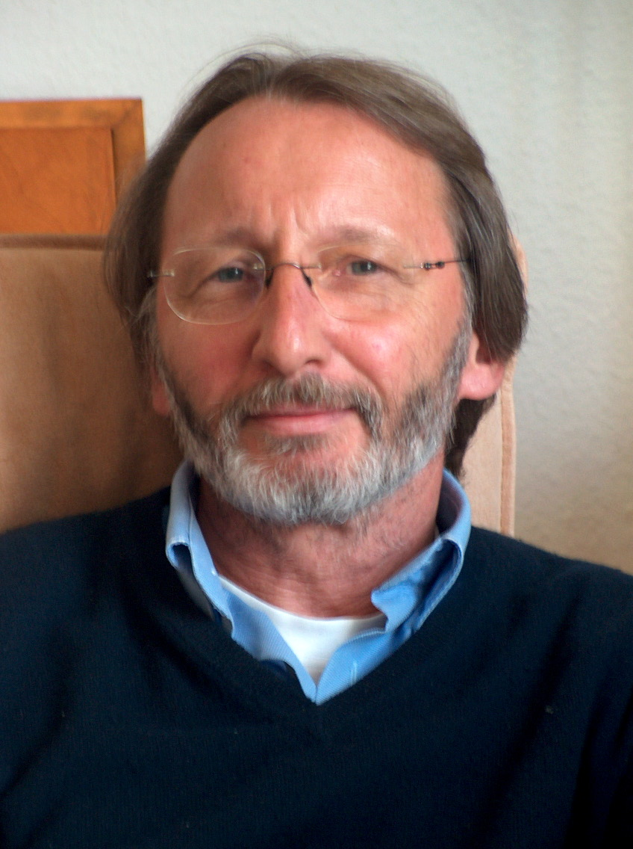
Gestalt Theoretical Psychotherapy as an Integrative Approach
We understand Gestalt Theoretical Psychotherapy as an integrative approach to psychotherapy. Basic insights as well as interventions of other psychotherapeutic schools can be (and have been) integrated into Gestalt Theoretical Psychotherapy as far as they are compatible with the overall concept of the method. This integrative orientation is outlined in the fourth lecture of our workshop.
Contact: praxis-kaestl@t-online.de

Thomas Fuchs
Society of Gestalt Theory and its Applications (GTA)

A Clinical Example
A case-vignette of a psychotherapy with a person suffering from eating-disorder. To illustrate some implications of the theoretical concepts presented in our workshops, this presentation will try to demonstrate the practical approach of the method. Further, some consequences of the previous postulations on the concepts of mental health and mental illness will be discussed.
Contact: ThomasFuchsPsycho@t-online.de

Workshop 2: Creative Workshop: HAIKUBOOKLET

Chiara Salvatore
Scuola di Gestalt Counseling (division of Alchimia, m.a.c.s. Srl)

Creative Workshop: HAIKUBOOKLET
A gym to increase the capacity for awareness of reality in a group context in which to test oneself in the communication of oneself, moving from perception to full contact which becomes experience and stratified identity that creates the unique and original individual. For Attendees there is a Certificate to be able to reproduce them in their context.
Contact: chiara.salvatore@alchimia.ws

Workshop 3: Laboratory of Experimental Eye Tracking Linguistics (LELO)
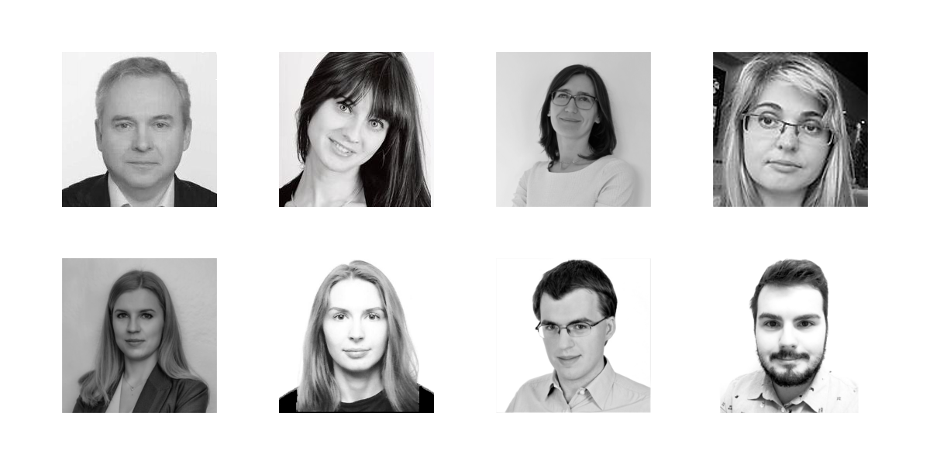
Team:; Monika Płużyczka (Head of the Laboratory); Agnieszka Andrychowicz-Trojanowska; Anna Bonek, Magda Żelazowska-Sobczyk; Maria Castelas, Dominik Kudła, Mateusz Patera. Prof. Sambor Grucza (Research Supervisor)
Link to the website: http://www.lelo.uw.edu.pl; http://pbe.uw.edu.pl/pl/
The Laboratory of Experimental Eye Tracking Linguistics (LELO) is a part of the Institute of Specialised and Intercultural Communication at the Faculty of Applied Linguistics, University of Warsaw. The Lab was established in 2012. The primary task of LELO was to initiate and develop in Poland research in the field of experimental eye tracking linguistics, especially translation-studies-oriented experimental research, as well as experimental glottodidactic research, leading to broadening the exploratory boundaries of these fields. So far the team co-organized two International Conferences on Eye Tracking and Applied Linguistics (ICEAL – Warsaw 2014, 2015) and was also a co-organizer of five editions of Polish Eye Tracking Conference (PKE – Warsaw 2013, 2015, 2016, 2017, 2018). The team is now conducting eye tracking projects concerning sight translation, written translation, perception and comprehension of legal texts, foreign language learning, glottodidactic materials, video games localization and computer-assisted translation tools. The workshop will present the Lab as well as the scientific projects conducted there. Every speaker will briefly present her/his scientific projects involving eye tracking experiments. As all the LELO members are linguists, it will be a chance to show how eye tracking can be utilized in the field of linguistics, translation studies and glottodidactics (i.e. foreign language teaching and learning) and what insight it provided into cognitive processes observed within these areas.

Posters

Yuliia Savchuk
Volyn Regional Psychiatric Hospital №1 of Lutsk

Psychological complexes: genesis and work over them
The work offers the methods for identification of the issue with self-esteem. It’s also offers the documented reactions on definite methods attributed to psychological session. Thе research distinctly illustrates the answer to the question concerning the genesis of the "paraphernalia" the individuals possess.
Contact: juli_v16yuv@ukr.net

Paweł Kluczek
Warsaw University

Motion in communication: borrowings in the gamers’ language
Communication can be also a space for motion. The case study for this poster is communication via on-line forums. The aim is firstly to create parallel language corpora of texts by English gamers and German gamers secondly, to search for most common hits, thirdly, these hits should help to make findings: trying to find out: why these loanwords work in such a way.
Contact: pawel.kluczek@gmail.com

Students of the Lab for Multimodal Communication – Movement in Communication: The Significance of Nonverbal Language
University of Warsaw, IKSI
The Lab for Multimodal Communication (LAKOM) (directed by Silvia Bonacchi) is a research unit of the Institute of Specialized and Intercultural Communication of the University of Warsaw and deals with multimodal analysis of face-to-face communication interactions and communication via the Internet (CMC ComputerMediatedCommunication). LAKOM is designed as a forum and platform for students and young scientists cooperating with experienced scientists in Poland and abroad.

Aneta Borowiecka, Kamil Böhm
The Body Language of Charisma

Maja Falkenberg, Klaudia Wielemborek
Gesten mit Mißverständnispotential

Organisation

Silvia Bonacchi
Warsaw University

Prof. Dr. Silvia Bonacchi, Linguist, research groups:„MCCA - Multimodal Communication: Culturological Analysis“ and LAKOM (Labor for Multimodal Communication Studies, University of Warsaw, Institute for Specialized and Intecultural Communication), co-chief-editor of „Gestalt Theory“. Publications (selected): „Verbale Aggression: Multidisziplinäre Zugänge zur verletzenden Macht der Sprache (ed. 2017) „(Un)Höflichkeit – Eine kulturologische Analyse Deutsch-Italienisch-Polnisch“ (2013), „Höflichkeitsausdrücke und anthropozentrische Linguistik“ (2011).
My contribution: Organisation and Logistics
Contact: s.bonacchi@uw.edu.pl

Jagna Brudzińska
Polish Academy of Sciences / University of Cologne

Jagna Brudzińska, PhD, Dipl. Psych., is Professor for Philosophy at the Institute of Philosophy and Sociology of the Polish Academy of Sciences, where she is the head of the Research Group „Philosophical Anthropology and Social Philosophy“. At the Husserl-Archive of the University of Cologne she is Research Fellow and editor of the critical edition of Edmund Husserl’s last work Experience and Judgment for the book series Husserliana. She is the scientific coordinator of the International Network Genetic Phenomenology and the Human Sciences. She is also a professional psychologist working in the area of psychoanalysis and qualitative research.
My contribution: Organisation and Logistics
Contact: jagna.brudzinska@uni-koeln.de

Alice Pugliese
University of Palermo

Assistant Professor of Moral Philosophy at the University of Palermo, Department of Humanities. She collaborates with the International Network gPhen – Genetic Phenomenology and the Human Sciences. Chief editor of the international journal Metodo. International Studies in Phenomenology and Philosophy – sdvig press - Lausanne. Main publications: 2009. Unicità e relazione. Mimesis; 2014. Il movente dell’esperienza. Costituzione, pulsione ed etica in Edmund Husserl. Mimesis. Triebsphäre und Urkindheit des Ich, Husserl Studies 2009. Subjektive und intersubjektive Genesis der Handlung, “Phänomenologische Forschungen”, 2013.
My contribution: Organisation and logistics
Contact: alice.pugliese@unipa.it

Mariusz Mela
Warsaw University
Contact: m.mela@uw.edu.pl

http://www.gtf-tanzforschung.de/tanzforschung/forschungsbereiche/ (25. April 2017)

